Project Implementation Directorate
Kathmandu Upatyaka Khanepani Limited
Anamnagar, Kathmandu, Nepal

Kathmandu Valley Water Supply Improvement Project, ADB Loan No. 3255

Quarterly Progress Report (October-December, 2018)

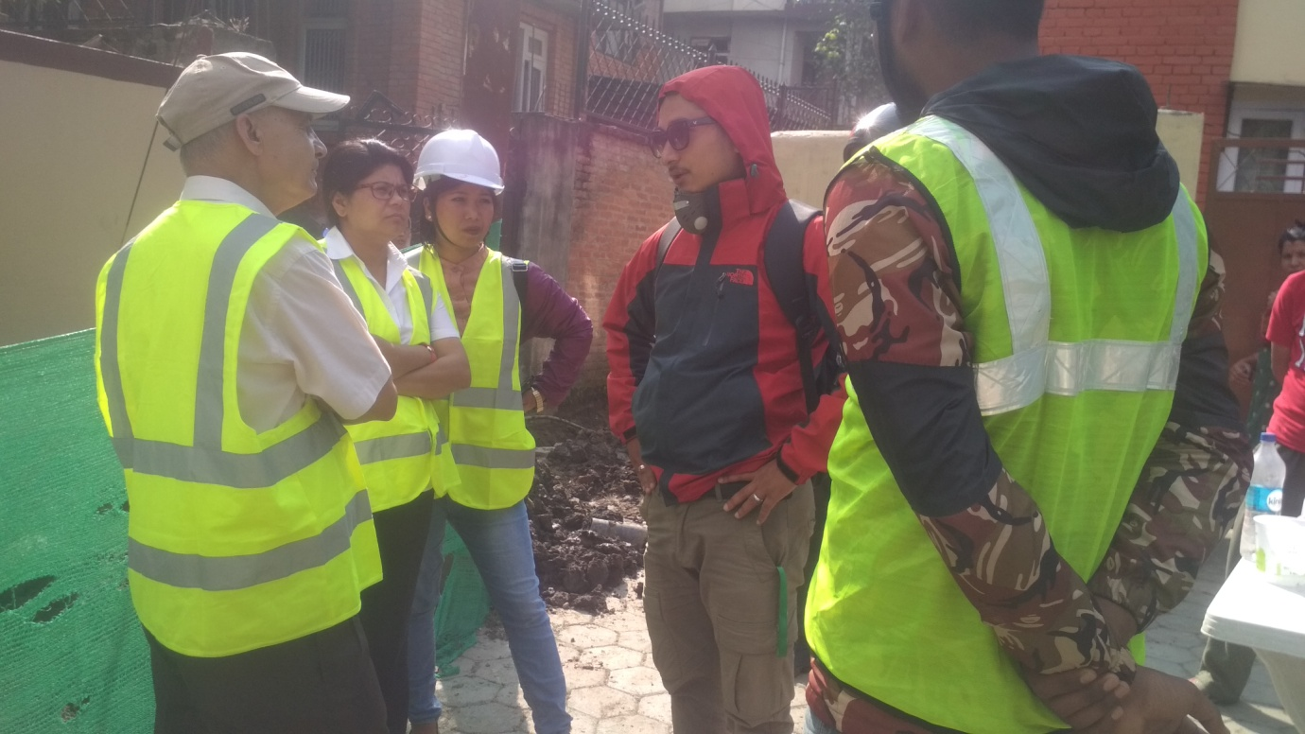

Environmental Monitoring and Safeguard Works

Prepared by
Dohwa Engineering Co. Ltd.
In association with the Sub consultants
Environment & Resource Management Consultant (P) Ltd.,
Building Design Authority (P) Ltd. and TAEC Consult (P) Ltd.

January, 2019

This Environmental Monitoring Report is a document of the borrower. The views expressed herein do not necessarily represent those of ADB's Board of Directors, Management, or staff, and may be preliminary in nature. Your attention is directed to the “terms of use” section of this website.
In preparing any country program or strategy, financing any project, or by making any designation of or reference to a particular territory or geographic area in this document, the Asian Development Bank does not intend to make any judgments as to the legal or other status of any territory or area.

Table of Contents
1 Introduction 1
1.1 Background 1
1.2 Loan received from ADB 1
a. Loan 3255 1
2 Institutional framework for Project Environmental Safeguards Compliance 2
3 Service Area and Position of SRT and BDS 3
3.1 Service Area SRT wise 3
3.2 BDS and SRT 3
4 Ongoing Works 4
4.1 Pipe Line Construction 4
4.2 Chambers Construction 4
4.3 Service Reservoir Tank Construction 4
4.4 Household connection 4
4.5 Reinstatement of Municipal Roads-1 4
5 Activities in this Quarter, 2018 5
5.1 ADB Mission 5
5.2 Letter(s)/Memo(s) 5
6 Environment, Safety and Health 5
6.1 Air Pollution Monitoring 5
6.2 Noise Pollution Monitoring 8
6.3 Water Quality and Waste Water Quality monitoring 9
6.4 SRT Monitoring 10
6.5 Pipeline Monitoring 10
6.6 Occupational health and safety (OHS) 13
6.7 Social Safeguards 15
7 Presentation on Environment, and Social safeguards 15
8 Others related to environment and safety issues 15
9 Grievance Redress 17
9.1 Grievance Redress Mechanism (GRM) 17
9.2 Formation criteria of GRM 17
9.3 Complaints Received during the Reporting Period and their resolution 19
10 Activities Planned for Next Quarter 20
11 Annex 21
I. Picture log 21
II. Letters and Memos 23
III. OHS Performance Indicator 24
IV. Grievances Records 25

1 Introduction

1.1 Background
The Kathmandu Valley Water Supply Improvement Project (KVWSIP) known as Melamchi Subproject-II is a Government of Nepal's "National Pride Project". It is under implementation of Government of Nepal with the financial assistance of ADB (Loan No 3255-NEP; Loan No 2776-NEP; and Loan-1820), the executing agency for the project Ministry of Water Supply and Sanitation (MWSS) and implementing agency Kathmandu Upatyaka Khanepani Limited, Project Implementation Directorate (PID). The project is ongoing since 2001 to fulfill water supply needs of citizens of Kathmandu Valley. The project is mainly working on establishing several layers of distribution network such as Bulk Distribution System (BDS), Distribution Network Improvement (DNI), District Metering Area (DMA) and Service Reservoir Tank (SRT) and completing previously ongoing projects.
ADB Safeguard Policy Statement 2009 required KVWSIP to develop a structured process of impact assessment, planning and mitigation to address the adverse effects of projects throughout the project cycle. Based on the environmental screening the project was classified as category 'B' project and an Initial Environmental Examination (IEE) was done to examine the proposed infrastructure components for the year 2012-2016 to ensure that it will not damage the environment and provide guidance for planning, construction and operation. In environmental examination, potential environmental impacts are identified, their significance assessed and strategies devised to avoid those impacts or reduce them to the acceptable level. The strategies called mitigation measures are carried forward into Environmental Management Plan (EMP). This EMP assigns responsibilities, timescales and performance indicators/standards for each mitigation measure- to make sure that they are implemented.
As a standard practice for ADB projects, EMP included in the bidding documents and civil contract work packages under the project. EMP implementation is regularly monitored by PID/KUKL and reports are disclosed on the ADB website. The project is under construction and therefore this report presents the environmental monitoring for the month of August 2017 which is in accordance with the ADB's Safeguard Policy Statement 2009.

1.2 Loan received from ADB

a. Loan 3255
Kathmandu Valley Water Supply Improvement Project - Additional Financing, the Project Implementation Directorate (PID), under the Ministry of Water Supply and Sanitation (MoWSS) through the government of Nepal has received the loan from Asian Development Bank (ADB) Loan No. 3255. PROJECT AGREEMENT dated 7 December 2015 between ASIAN DEVELOPMENT BANK (“ADB”) and KATHMANDU VALLEY WATER SUPPLY MANAGEMENT BOARD (“KVWSMB”); MELAMCHI WATER SUPPLY DEVELOPMENT BOARD (“MWSDB”); and KATHMANDU UPATYAKA KHANEPANI LIMITED (“KUKL”). The Asian Development Bank (ADB) has approved loan of $ 90 million for the KVWSIP-AF. Government of Nepal (GON) will contribute US$ 45 million totaling the project cost US$ 135 million.
The project Area under Kathmandu Valley Water Supply & Sanitation Project (Melamchi Water Supply Project- Subproject 2) under ADB Loan No. 3255 lies in DNI package 4 (7a), and BDS package 4.

2 Institutional framework for Project Environmental Safeguards Compliance
In order to streamline the environmental safeguards implementation and monitoring PID has developed the following structure.

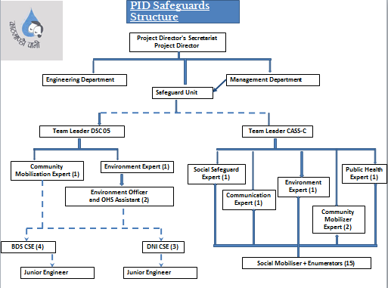

3 Service Area and Position of SRT and BDS

3.1 Service Area SRT wise
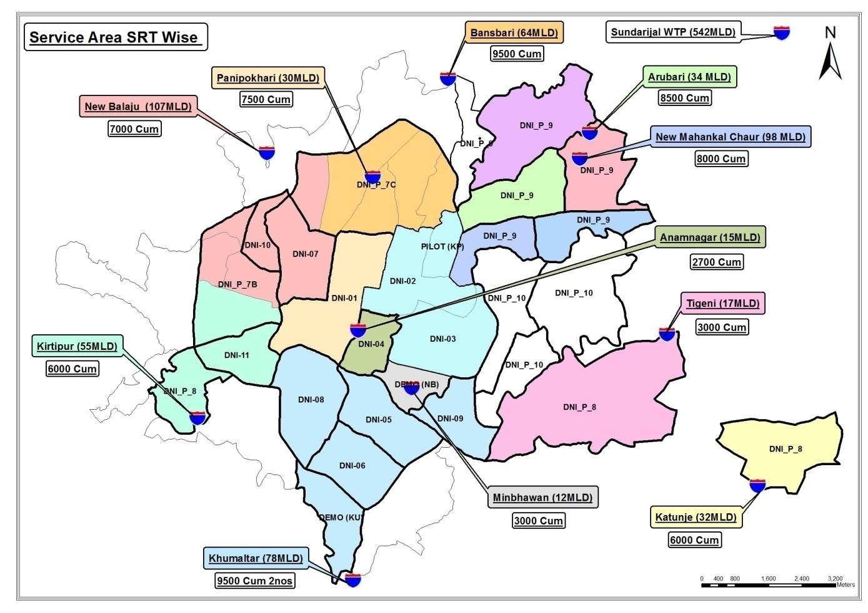

3.2 BDS and SRT

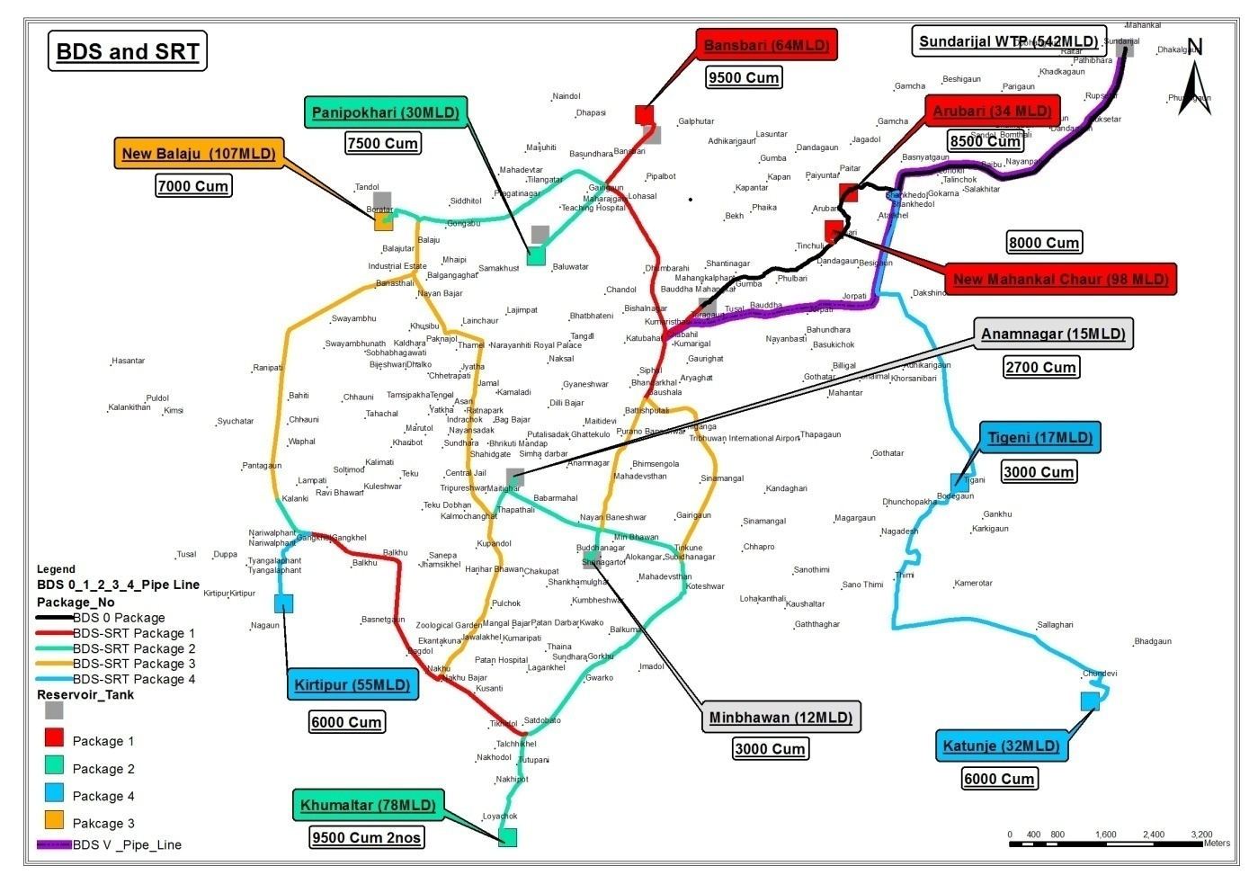

4 Ongoing Works
The ongoing works for the project are pipelines, SRTs and chamber constructions.

4.1 Pipe Line Construction
In terms of pipe line connection, 21.54% for DNI and 79.58% for BDS of pipeline work has been completed. 10.87% of household connection work has been completed till this quarter. The contract wise update is given in Table 4.1 below.
Table 4.1: Pipe line construction progress in DNI and BDS
Contract No | Progress till this month in % | Contract No | Progress till this month in %
DNI-4-7A | 21.54 | BDS-4 | 79.58
Average progress | 21.54 | Average progress | 79.58

4.2 Chambers Construction
Chambers (Pressure test/Fire hydrant, Bulk Flow Meter, Butterfly Valve/Line Valve/Gate Valve and Press Reducing Valve) were 13.47% for DNI and 42.3% for BDS constructed till this quarter. The contract wise update is given in Table 4.2 below.
Table 4.2: Chamber construction progress in DNI and BDS
Contract No | Progress till this month in % | Contract No | Progress till this month in %
DNI-4-7A | 13.47 | BDS-4 | 42.3
Average progress | 13.47 | Average progress | 42.3

4.3 Service Reservoir Tank Construction
Out of all SRTs 57.82% works have been completed till this quarter. The contract wise update is given in Table 4.3 below.
Table 4.3: SRT construction progress
Contract No | Progress till this month in %
BDS-4 | 57.82
Average progress | 57.82

4.4 Household connection
Out of all household connections 10.87% works have been completed till this quarter. The contract wise update is given in Table 4.4 below.
Table 4.4: Household connection progress
Contract No | Progress till this month in %
DNI-4-7A | 10.87
Average progress | 10.87

4.5 Reinstatement of Municipal Roads-1
24.49 % works have been completed till this month.

5 Activities in this Quarter, 2018

5.1 ADB Mission
There has been no any ADB mission in this quarter.

5.2 Letter(s)/Memo(s)
Various letters were issued by DSC 05 regarding environment and OHS to contractors instructing them to comply on various topics. Similarly, on the same contractors have been submitting completed checklists to DSC 05 via letter. Copies of all letters are attached in annex.
25th October: Regarding methodology for excavation and soil management of DNI 7A.
4th October: Submission of bimonthly Safety Toolbox Talk record, monthly MRM, monthly OHS Performance Indicator, Bimonthly Site Housekeeping Checklist Record submitted by DNI 7A.
8th October: Coordination and Facilitation for land Acquisition Process at Katunje and Tigeni.
1st November: Regarding Safeguards at work spots of DNI Package 7a.
5th November: Safeguard at work sites BDS Package 4.
15th November: Bimonthly site housekeeping checklist DNI 7a.
21st November: Submission of Terms of Reference (TOR) of DNI 9a-1.
5th November: Submission of bimonthly Safety Toolbox Talk record, Monthly OHS Performance Indicator, Housekeeping Checklist by DNI 7a.
4th November: Submission of OHS Performance Indicator Checklist by BDS Package 4 via mail.
20th December: Submission of Bimonthly Safety Toolbox Talk, Housekeeping Checklist by DNI 7a.
26th December: Submission of Monthly OHS MRM by DNI 7a.
26th December: Letter sent by PID regarding Approval of TOR for IEE of Kapan DNI 9A1 from Ministry.
5th December: Letter sent to PID regarding commitment to submit TOR of IEE and DDR report for BDS 5 and DNI Package 7B and 7C.

6 Environment, Safety and Health

6.1 Air Pollution Monitoring
Background
Air pollution is the human introduction of chemicals, particulate matter, or biological materials that cause harm or discomfort to humans or other living organisms, or damages the environment into the atmosphere. Air pollution causes deaths and respiratory disease. Air pollution is often identified with major stationary sources, but the greatest source of emissions is mobile sources, mainly automobiles. Gases such as carbon dioxide, which contribute to global warming, have gained recognition as pollutants by climate scientists, while they also recognize that carbon dioxide is essential for plant life through photosynthesis.
An air pollutant is known as a substance in the air that can cause harm to living beings and the environment. Pollutants can be in the form of solid particles, liquid droplets, or gases. In addition, they may be natural or man-made.
Air is one of the most vulnerable components of the environment. Activities like quarrying, blasting and excavation, disposal of the spoils, blasting of the rocks and other constructional activities within the project area seriously deteriorate the air quality. Furthermore, emission from increased number of vehicles, re-suspension of the road dust by fleeting vehicles, operation of the various types of power generating equipments all contribute to the increase of air pollution within the project area. Similarly, the increase in human population is also responsible to some extent for the increased air pollution. Vehicular and mass activity increases the particles of dust and emission of unwanted gases into the atmosphere which has direct impact on the human health.
Air pollution, in the work area, is measured by using high/ low volume air sampler. The methodology is described precisely.
High and low volume air samplers
High and low volume air samplers are instruments used to collect samples of air particles. The difference between high and low volume air samplers is the amount of air sampled. High volume air samplers typically sample more than 1500 cubic meters (m³) of air over a 24-hour period, while low volume air samplers draw through only 24 m³ of air, or less.
Total suspended particulate matter (tsp)
TSP monitoring measures the total amount of particles suspended in the atmosphere. An instrument called a high volume air sampler is used to collect TSP samples. The high volume air sampler draws a large known volume of air through a pre-weighed filter for 24 hours.
As shown in the diagram below, the sampler filter traps the TSP particles as air passes through the instrument.
After sampling, the filter is re-weighed and the difference in filter weight is the collected particulate matter mass. Dividing the mass by the volume of air sampled gives the concentration of TSP.
Particles less than 10 micrometers in diameter (PM₁₀)
Particle less than 10 µm are especially concerning as these particles can enter the human respiratory system and penetrate deeply into the lungs, causing adverse health effects. Motor vehicles and other combustion processes that burn fossil fuels such as power stations, industrial processes and domestic heaters, generate PM₁₀. Dust storms and smoke particles from bushfires can also be another source of PM₁₀missions.
Instruments used to measure PM₁₀ are either a high or low volume air sampler
The PM₁₀ high or low volume air sampler is similar to that described above for TSP, except that the air sample passes through a size-selective inlet. The inlet removes particles larger than 10µm by using their greater inertia to trap them on a greased plate, while smaller particles pass through the instrument onto the pre-weighed filter.
The diagram of a high volume sampler shows this.
Measuring the volume of air sampled and weighing the filters before and after sampling determines the concentration of PM₁₀ particles in the air.
Ambient air in the project surroundings are not only impacted by the project construction activities but also it is being impacted by the other stakes also. Main causes of the air pollution are heavy traffic, various construction works by the stakeholders and existing road conditions
Diagram of a PM₁₀ sampler
Air pollution (AP) is the most alarming grievance by the people. AP has not been monitored for all the contract packages BDS and DNI at their work places by the respective contractors and can be seen in Table 6.1.1.

Table 6.1.1: Air pollution monitoring
Site No. | Date of Testing | Site Location | Date/  Time | Parameters
 |  |  |  | TSPM  µg/m3 | PM₁₀ µg/m³ | PM_{2.5} µg/m³ | SO2 µg/m3 | NO2  µg/m3
Government Standards |  |  |  | 230 | 120 | 40 | 70 | 80
BDS-4 | NA | NA | NA | NA | NA | NA | NA | NA
DNI-7A | NA | NA | NA | NA | NA | NA | NA | NA
Municipal Road Reinstatement | NA | NA | NA | NA | NA | NA | NA | NA
The ambient air quality during no construction work condition is also alarming and during the construction progress is highly alarming. The same situation is still standing. The water sprinkling is the method to suppress the air dusts in the construction sites. The suppression of dusts is being done by the contractors by sprinkling the water three to four times a day. This has helped to decrease the air pollution in the surrounding.

6.2 Noise Pollution Monitoring
Noise is considered as a serious environmental hazard. Noise can be defined as “any sound that is undesirable because it interferes with speech and hearings, is intense enough to damage hearing, or is otherwise annoying”. The definition of noise as unwanted sound implies that it has an adverse effect on human beings and their environment, including infrastructures and domestic animals. Noise pollution affects both health and behavior. Unwanted sound (noise) can damage psychological and physiological health. Noise pollution can cause hypertension, high stress levels, tinnitus; noise induced hearing loss, sleep disturbances, and other harmful effects.
Sound becomes unwanted when it either interferes with normal activities such as irritation from vehicles horns, sleep, conversation, or disrupts or diminishes one's quality of life.
Chronic exposure to noise may cause noise-induced hearing loss. Older males exposed to significant occupational noise demonstrate more significantly reduced hearing sensitivity than their non-exposed peers, though differences in hearing sensitivity decrease with time.
High noise levels can result in cardiovascular effects and exposure to moderately high levels during a single eight-hour period causes a statistical rise in blood pressure of five to ten points and an increase in stress, and vasoconstriction leading to the increased blood pressure noted above, as well as to increased incidence of coronary artery disease.
During the construction of any developmental project, activities like blasting, drilling and vehicular movement, power tool operation may generate unacceptable noise levels that may seriously deteriorate the environment and may cause detrimental impacts on human beings and other ecological components.
As per the National Ambient Sound Quality Standards the sound level is to maintained 75 dB(A) for the day time and 70 dB(A) in the night time which is mentioned in Table 6.2.1 is taken as the noise level as the works are carried at construction sites.
Table 6.2.1: National Ambient Sound Quality Standards of Nepal-2012
S.N. | Area | Noise Level dB(A)
 |  | Day time | Night time
1 | Industrial Area | 75 | 70
2 | Commercial Area | 65 | 55
3 | Urban Residential Area | 55 | 50
4 | Rural Residential Area | 45 | 40
5 | Mixed Residential Area | 63 | 55
6 | Peace Area | 50 | 40
Sound level is measured by using precise decibel sound meter at all the sites.
Noise Pollution monitoring has not been done by the contractor in this quarter. Report of noise monitoring done by consultant is in table 6.2.2.
Table 6.2.2: Noise Pollution monitoring
Contract Pkg | Date and time |  |  | Site Location |  |  | LA_{eq} (dBA) |  |  |  |  |  | Condition
 | O | N | D | O | N | D | Day Time |  |  | Night Time
 |  |  |  |  |  |  | O | N | D | O | N | D
Government standards |  |  |  |  |  |  | 75 | 75 | 75 | 70 | 70 | 70 | Industrial area (for Construction site)
Monitoring by Contractors
All Packages | NA | NA | NA | NA | NA | NA | NA | NA | NA | - | - | - | -
NR=Not recorded, NA=Not available, TBA= To Be Available

6.3 Water Quality and Waste Water Quality monitoring
Water is one of the most important components of the environment and can be deteriorate through various anthropogenic activities. Therefore, it is necessary to utilize manifold evaluation of water quality characteristics in order to develop a total evaluation of existing water quality as well as micro scale changes that result from project activities in the water bodies. Any construction activity at the upstream or downstream of a River and nearby water sources degrades the water quality.
The EMP team has fixed their camp locations for water sampling. The samples were collected in disinfected pet bottles and tested in the laboratory as per the IEE requirement for drinking water and waste water coming to the inland water from the contractor's camps.
Contractors did not do the water quality and waste water quality monitoring in this quarter. The basic quality needed for the drinking purpose is shown in Table 6.3.1.
Table 6.3.1: Water quality at various sites
Parameters | Units | WHO GV | NDWQS | DNI-7a |  |  | BDS-4 |  |  | Methods used
 |  |  |  | O | N | D | O | N | D
Color | Hazen | 15 | 5(15) |  | - |  | - | - | -
Turbidity | NTU | 5 | 5 (10) |  | - |  | - | - | -
Total Dissolved Solids | mg/l | 1000 | 1000 |  | - |  | - | - | -
Conductivity | µS/cm | - | 1500 |  | - |  | - | - | -
Taste | TFN | - | Not Objectionable |  | - |  | - | - | -
Odour | TON | - | Not Objectionable |  | - |  | - | - | -
pH | - | 6.5 - 8.5 | 6.5-8.5* |  | - |  | - | - | -
Chemical
Total Hardness | mg/l as CaCO₃ | 500 | 500 |  | - |  | - | - | -
Calcium | mg/l | - | 200 |  | - |  | - | - | -
Chloride | mg/l | 250 | 250 |  | - |  | - | - | -
Ammonia | mg/l | 1.5 | 1.5 |  | - |  | - | - | -
Iron | mg/l | 0.3 | 0.3 (3) |  | - |  | - | - | -
Arsenic | mg/l | 0.01 | 0.05 |  | - |  | - | - | -
Copper | mg/l | 2 | 1 |  | - |  | - | - | -
Nitrate | mg/l | 50 | 50 |  | - |  | - | - | -
Aluminum | mg/l | - | 0.2 |  | - |  | - | - | -
Cyanide | mg/l | - | - |  | - |  | - | - | -
Mercury | mg/l | 0.001 | 0.001 |  | - |  | - | - | -
Cadmium | mg/l | 0.003 | 0.003 |  | - |  | - | - | -
Lead | mg/l | 0.01 | 0.01 |  | - |  | - | - | -
Free Residual Chlorine | mg/l | 0.5 | 0.1-0.2* |  | - |  | - | - | -
Chromium | mg/l | 0.05 | 0.05 |  | - |  | - | - | -
Sulfate | mg/l | - | 250 |  | - |  | - | - | -
Manganese | mg/l | 0.4 | 0.2 |  | - |  | - | - | -
Zinc | mg/l | - | 3 |  | - |  | - | - | -
Fluoride | mg/l | 1.5 | 0.5-1.5* |  | - |  | - | - | -
Biological
Total Coli forms | CFU/100ml | Nil | Nil |  | - |  | - | - | -
E. Coli | CFU/100ml | - | - |  | - |  | - | - | -
Table6.3.2: Waste Water Quality Monitoring
Site No. | Date of Sampling | Site Location | Parameters (Government Standards)
 |  |  | pH | Conductivity µS/cm | BOD mg/L | TSS mg/L | TN mg/L | TP mg/L
All sites |  |  | 5.5-9.0 | - | 50 | 50 | - | -
DNI-7A | NA | NA | NA | NA | NA | NA | NA | NA
BDS-4 | NA | NA | NA | NA | NA | NA | NA | NA
Reinstatement of Municipal Road-1 | NA | NA | NA | NA | NA | NA | NA | NA

6.4 SRT Monitoring
Out of 1 SRT site monitoring it was found that it achieved above 60. Table 6.4.1 shows the compliance status of SRT. A separate checklist for scaffolds and accommodation has been filled at all SRT sites as well.
Table 6.4.1: Compliance Monitoring Status of SRT
S N | Date | Location | Name of contractor | Package | Achieved score % | Compliance status
¹ | 01-10-18 | Kirtipur | Hangzhou-Ashish | BDS 4 | 62 | ^{Good}

6.5 Pipeline Monitoring
The average scores of pipeline monitoring regarding environmental and concerns are shown in Table 6.5.1 and 6.5.2.
Table 6.5.1: Compliance Monitoring Status of Pipelines
^{S N} | ^{Date} | ^{Location} | ^{Name of contractor} | ^{Package} | ^{Achieved score %} | ^{Compliance status}
1 | 03-10-18 | Balkhu | GIETC-Sharma-Raman JV | DNI 7A | 43.88 | ^{Poor}
2 | 03-10-18 | Kuleshwor | GIETC-Sharma-Raman JV | DNI 7A | 47.59 | ^{Poor}
3 | 29-10-18 | Balkumari | GIETC-Sharma-Raman JV | DNI 7A | 64 | ^{Good}
4 | 05-11-18 | Kalanki | GIETC-Sharma-Raman JV | DNI 7A | 16.67 | ^{Very Poor}
5 | 27-11-18 | Balkumari-1 | GIETC-Sharma-Raman JV | DNI 7A | 46.94 | ^{Poor}
6 | 27-11-18 | Balkumari-2 | GIETC-Sharma-Raman JV | DNI 7A | 58.33 | ^{Poor}
7 | 30-12-18 | Balkumari | GIETC-Sharma-Raman JV | DNI 7A | 48.2 | ^{Poor}
A total of 7 sites were monitored for pipe laying, only 1 site has achieved 60% and 5 sites have achieved below 60% compliance. The DNI 7a package although has maintained barricades and placement of signage boards, it still has not been able to do temporary shifting of soils, hence it has been receiving poor scores.
Table 6.5.2: Average score of checklist

Kathmandu Valley Water Supply Improvement Project
Project Implementation Directorate, Kathmandu Upatyaka Khanepani Limited
Name of Work:
Name of Contractor:
Contract No: |  |  | Monitoring Date
 |  |  | Time
Place:
SN | Subject | Activities | Yes | No | Full Score | Achieved Score |  | Remarks
 |  |  | √ | X
1 | Signage | Available Sign Board with the Name of Project & Contractor |  |  | 3 | 3 |  | Satisfactory
 |  | Available Visible Sign Board for Traffic Alternative Route |  |  | 2 | 1.71 |  | Satisfactory
2 | Health & Safety | Available of authorized representative of contractor at work site (Engineer/Supervisor) |  |  | 3 | 2.57 |  | Satisfactory
 |  | Regular visit of work area for supervision by contractor's Safety supervisor |  |  | 3 | 1.28 |  | Satisfactory
 |  | Hard Barricading for Working Area: Minimum 4 ft. height Metal posts with Nylon Ropes/Green net in 3 rows for BDS/DNI works and danger light (for night work) on Non-Black topped Roads (Primary line) |  |  | 4 |  |  | Not Applicable
 |  | Metal hoarding/Sheet fence (Safety Barrier) for BDS & DNI Primary line works on Black topped Roads Available |  |  | 4 |  |  | No primary line work
 |  | Hard Barricading for Working Area: Minimum 4 ft. height Metal posts with Nylon Ropes in 3 rows for DNI works on Non-Black topped/Black topped Roads Available |  |  | 4 | 2.41 |  | Satisfactory
 |  | Entry of Non-Authorized Person inside the area of Safety Barriers |  |  | 3 | 1.28 |  | Satisfactory
 |  | Trench Shoring for BDS & DNI Primary line Available |  |  | 4 |  |  | Not Applicable
 |  | Use of Personnel Protective Equipments (PPEs) by Workers i.e. hard helmets, PPE vest, Gloves, Safety Glasses, Boots, Masks etc and mention in remarks the % of use and which PPEs is not used. |  |  | 7 | 4.28 |  | Satisfactory
 |  | Grant of Permission for entry inside the work areas with safety barrier to the site engineer and other construction personnel without the use of PPEs such as Hard helmets and Reflector Jacket. |  |  | 2 | 0.71 |  | Not Satisfactory
 |  | First Aid Box at Working Area Available |  |  | 4 | 0.57 |  | Not Satisfactory
 |  | Drinking Water at Working area Available |  |  | 2 | 2 |  | Satisfactory
3 | Grievances Redress Mechanism | Help Desk: Table, Chair and First Aid with Grievance Register Available visible by Public |  |  | 3 | 1.28 |  | Satisfactory
 |  | Helper at Help Desk Available |  |  | 2 | 0.14 |  | Not Satisfactory
4 | Traffic and Pedestrians Access without obstruction and Housekeeping of work area | Cross over metal platforms on trench of BDS & DNI Pipeline work Available |  |  | 3 | 0 |  | Not Satisfactory
 |  | Availability of platforms on loose soil and Pit for safe pedestrians Access |  |  | 3 |  |  | Not Applicable
 |  | On basis of width of Road, Availability of half portion of road is open for Traffic and Pedestrians Access during construction |  |  | 5 | 2.62 |  | Satisfactory
 |  | Cleanliness of Working Area and Access Road by immediate removal of loose soil, dust, aggregated and excavated soil |  |  | 8 | 1.71 |  | Not Satisfactory.
 |  | Excess soil to be removed after the laying pipe in trench with house connection, backfilling and compaction in BDS and DNI Work on any Road |  |  | 15 | 7 |  | Satisfactory
 |  | Availability of Safety Barrier at Pits excavated for house connection and Pressure test, If work is not immediately completed |  |  | 5 |  |  | Not Applicable
5 | Damages/Repairs in Service Sector | Availability of record keeping system for damages in private and social structure |  |  | 3 | 0.71 |  | Not Satisfactory
 |  | Leaving pipe laying area clean with compaction in previous condition after pipe laying in road for each 30 m stretch |  |  | 5 | 2.5 |  | Satisfactory
 |  | Temporary reinstatement of black topped road shall be done within 2 days in BDS & DNI Pipeline work |  |  | 3 | 3 |  | Satisfactory
 |  | TOTAL |  |  | 80 | 38.77  i.e. 48.46 |  | Not Satisfactory

6.6 Occupational health and safety (OHS)
Efforts have been made by PID, DSC 05 and contractors in collaboration with ADB's consultant in terms of Occupational Health and Safety. Understanding the lack of awareness and implementation of occupational health and safety (OHS) aspects in this project; this quarter a lot of effort was made to OHS to kick start it in the project.
- HIRAC and OHS MRM: HIRAC and first MRM for all DNI and BDS Packages were completed by January, 2018. HIRAC is to be updated in every 6 months and MRM is to be done in every 3 months (minimum). DSC 05 has instructed their contractors to conduct MRM every month in-order to maintain the system in place. As per schedule review of the previous HIRAC for all DNI and BDS Packages were completed and MRM was conducted in presence of OHS team. The contractors have been conducting MRM monthly and they have sent the agenda to DSC 05 accordingly.

- Checklists: Contractors have been provided with numerous checklists to provide DSC 05. The checklists issued to contractors are OHS Audit, Worker's Accommodation. Scaffold, Housekeeping, Office Ergonomics, Work at Height, Equipment Inspection and Maintenance and Excavation Works.

- OHS Performance Indicator: Out of 2 ongoing packages both packages have sent their OHS Performance Indicators in this quarter.

- Health Surveillance: Till date out of 2 Packages only 1 contractor i.e. DNI 7A have conducted health surveillance of their workers.

- Scaffold Inspection: Scaffold inspection is applicable for BDS packages only i.e. contractors with SRTs. 1 Package have submitted their scaffold checklist.

- Accommodation: It was instructed to all contractors to inspect the accommodation of their labours (provided by the contractors) as per the checklist provided by DSC 05 in every 3 months. 2 out of 2on going packages i.e. DNI Package 4 and BDS 4 have completed first inspection of the accommodation and submitted to DSC 05. DNI Package 7A and BDS Package 4 needs to complete its second worker's accommodation inspection.

- Internal OHS Audit: There was no any system of OHS internal audit amongst all contractors. After ADB OHS consultant's external audit on October, a checklist for OHS audit was sent to all contractors by DSC 05 to be conducted once in a year. Internal OHS audit was conducted by 1 out of 2 ongoing contract packages i.e. DNI Package 7A submitted to DSC 05.

- Housekeeping: Considering the emphasis ADB, PID and DSC has been giving on housekeeping considering its importance on safety and safeguards of workers as well as the community. A housekeeping checklist was developed and contractors were instructed to submit it bimonthly. Out of 2 packages 1 packages i.e. DNI Package 7Ahave sent housekeeping checklist to DSC 05. BDS Package 4 has not submitted its housekeeping checklist at all in this quarter.

- Toolbox Talk: As per ADM mission (2017) recommendation, contractors were instructed to conduct toolbox talk on various topics as per need. This quarter DNI Package 7A has submitted its toolbox talk report however BDS Package 4 has not submitted its toolbox talk report at all in this quarter.

- OHS Management Review Meeting (MRM): All the contractors have been instructed to conduct OHS MRM each month as per the agendas developed by ADB OHS consultant. MRM is to be conducted in every 3 months however to get the system in place, the contractors have been conducting MRMs every month. In last three months all 2 packages have conducted at least one OHS MRM.MRM was conducted in presence of OHS team.

- Office Ergonomics: A checklist for office ergonomics was provided by DSC 05 to all the contractors to be used. This quarter all contractors i.e. 2 out of 2 packages have submitted the office ergonomics checklist to DSC 05.

6.7 Social Safeguards
Social safeguard is an important issue for the project. It covers compensation, resettlement, rehabilitation for the affected in the construction area due to destruction and damage from the construction activities. Some of the works recently done in the social safeguard areas are;
- The land issue of SRT and pipe laying at Katunje alignment is in the process of resolving. PID has published information notice for land acquisition and the GRM sub-committee has formatted the compensation to distribute.
- Due Diligent Report (DDR)/Resettlement Plan (RP) for DNI 7B and 7C has been prepared and submitted to PID. The DDR/RP for BDS-5 will be submitted by Mid-January.

7 Presentation on Environment, and Social safeguards
An online orientation was provided to PID, DSC and CASSC safeguards teams on 5th July, 2018 by ADB.
- A meeting was held with Contractor's Representatives of all packages on 3rd October, 2018. The meeting was organized by ADB regarding the contractor's non compliance on safeguards. The contractors were made aware of their shortcomings and advised to comply with all safeguards issues in parallel with technical works.
- A meeting was held with PID Safeguard Unit regarding preparation of TOR for IEE of DNI 9-A-1. The TOR has been completed and submitted to PID by DSC 05.
- Workshop on Safeguards Compliance was organized by PID Safeguard Unit on 7th December, 2018. The workshop was conducted in presence of ADB, PID, DSC and CASSC.
- A 5 day training on Professional Environmental Safeguards was organized by Capacity Development Resource Centre, Nepal Administrative Staff College on 16-20th December, 2018

8 Others related to environment and safety issues
There are several things to be managed by the contractors as the result of constructional activities in the project construction sites. These are briefly described as below.
TOR for BDS 5, DNI 7B, DNI 7C: TOR for IEE has been prepared and submitted by DSC 05 for 3 new upcoming packages i.e. BDS 5, DNI 7B and DNI 7C.
TOR for 9-A-1: TOR for IEE has been prepared by DSC 05 in collaboration with CASSC and PID Safeguard Unit.
Safeguards Manual: The safeguards team from DSC/CASSC has been working together with Safeguards Unit team to prepare a safeguards manual. So far an outline for environment and OHS manual has been prepared.
Temporary Shifting of Stockpiles (DNI 7A): For areas having narrow road, it is not possible to bring dump truck, hence the CR of the package DNI 7A has submitted proposal of alternative way to remove excavated materials from the site. The proposal has been rejected by DSC 05, because it was unreasonable.
Child Labor: Child labors at all work sites are strictly prohibited. In-order to ensure that there are no any child labors working at our sites, a surprise site inspection was done in this quarter i.e. month of July. It was seen that none of the sites have employed labors under the age of 16, which is in compliance to Nepal's Labor Law.
Barricades, signage: Whenever there is any construction work to start, barricading and signage are placed properly to prevent any untoward accidents due to the construction activities. This quarter i.e. month of July, it was ensured that all sites have information boards at sites with all the details correctly written.
Muddy Water: Muddy water escaping the boundary can be seen during rains. To manage the problem Kathmandu Municipality does not allow the work in the rainy season.
Soil erosion: Since the construction area is located in gently flat area in Kathmandu valley, no such erosion is expected during heavy rains.
Concrete works: The designated concrete areas are Service Reservoir Tanks (SRT), thrust blocks and chambers. The works are carried out giving care about environment, safety and health of the workers and personals of the contractors.
Chemical storage: Chemical are stored in SRT construction area.
Construction materials: Construction materials like aggregates, sands, cement, reinforcement rods, pipes and plasticizer are stored normally in the SRT locations. Contractor has no crushing plant in the project area. All of them transport the approved size of crushed aggregates and sand form the approved crushing plants and quarries respectively and store required quantity in the SRT site area. The all above materials must screen with the required tests.
Refueling: Since construction area is entirely in Kathmandu valley, contractors do the refueling in the gas stations. But they need to keep the gases at their own store at least for 15 days need for their works in the time of emergency. Only the contractor of DNI-1, DNI-4-7A and BDS-3 has this facility in Sundarighat camp site. Other contractors do not have this facility.
Spill kits: One contractor of BDS-2 has spill kits facility in the camp at Khumaltar. Other contractors have no any spill kit in their sites. The Consultant advised the contractors to manage the proper spill kits for the emergency use to handle the spill of lubricants.
Management of solid and liquid wastes on-site: Normally solid wastes generated in the camp by 50 workers are 200 kg per week. This solid waste is collected by the waste collectors of the area and they manage by dumping to the notified dumping sites. Liquid wastes are sending to the sewerage system of the area.
Activities being under taken out of working hours: Labor Law Act of Nepal defines 8 hrs working time per day. For out of hour's activities, Contractor pays extra benefits to the workers as per Labor Law. Normally, pipe line works and chamber construction takes place in the night to minimize the traffic problem
Chemical storage: Plasticizers in the packed drums are kept at the SRT construction sites by the contractors. Some contractor has stored in the open shades made of corrugated CGI sheets and someone has stored in the closed rooms.
Management of stockpiles and excavated soils: The stockpiling of, DNI-7A, stock piles are stored in Sundarighat in Kathmandu and Lalitpur area. BDS-4 contractor has stored and stockpiled the materials in Kirtipur SRT area. Some of the construction materials Municipal road reinstatement works materials are stored in Koteswor, Mahadevsthan area. In the time of need these materials are transported in the location of construction activities. The excess materials are sent back to the stores by the contractors. The excavated soils are refilled back to the trenches. The excess soils are sent to the store area to upgrade low lands.

9 Grievance Redress
PID/KUKL is responsible for handling the issues/ complains/ problems raised by the local people, land owners regarding the loss or disturbance on livelihood, health, water, sanitation and other types of utilities during the construction period. For this, then CAPC and now Community Awareness and Safeguard Support Consultant (CASSC) are assisting PID/KUKL in handling those grievances. At this stage, PID/CASSC is handling those issues at the construction site regularly as per ADB’s Safeguard Policy and Government of Nepal’s safeguards frameworks. A Grievance Redress Mechanism (GRM) has been established in different level to address and provided orientation to receive, evaluate and facilitate to resolve the grievances of the affected people/family, concerned community. The GRM examines grievances about losses, compensation, social and environmental safeguard issues at local level and forwards the cases to different levels, if not resolved locally. The GRM aims to provide a trustable environment to address affected people’s concerns.

9.1 Grievance Redress Mechanism (GRM)
There are four levels of GRM. If they are not redressed in the first level of GRM, it will follow the subsequent levels. If it is not redressed in the fourth level too the case goes to the court and court's verdict will be final. It follows the path as mentioned Schematic Diagram of Grievance Redress Mechanism in the Fig 9.1

Grievance Redress

Contractor/ DSC-5/CASSC/ KUKL Branch Office
1st Level Grievances

If not redressed
1-3 days

-2 Days
Grievance Redress

Safeguard Unit/DSC-5/CASSC
2nd Level Grievances

If not redressed
7 Days
Grievance Redress

PD/Grievance Redress Committee
3rd Level Grievances

15 days
If not redressed

Higher Authority DAO/
Ministry/Court
4th Level Grievances

Figure-9.1: Schematic Diagram of Grievance Redress Mechanism (GRM)

9.2 Formation criteria of GRM
A grievance redress mechanism (GRM) has been established (safeguard officer from PID, safeguard expert from DSC, CASSC, contractor and TLO member) in PID to receive, evaluate, and facilitate the resolution of affected people’s concerns, complaints, and grievances about the social and environmental performance at the level of the project. A Community Issue Resolution Team (CIRT) is also established to address the grievances immediately in the field level. The Safeguard officer from PID has been assigned as coordinator for grievance handling. The GRM aims to provide a trusted way to voice and resolve concerns linked to the project, and to be an effective way to address affected people’s concerns. The GRM for the project is outlined below, and consists of three levels with time-bound schedules and specific persons to address grievances.

A First level of GRM

The first level GRM is a most accessible and immediate contact for the fastest resolution of grievances by CIRT (contractors, CASSC, TLO member and DSC supervisor) on site. Prior to construction of any works, CASSC, DSC, and contractors holds local community meetings and form local tole committee to notify the local residents about ongoing project’s objective, assess the impact of land, houses, trees, road, businesses etc. and inform to the project Implementation Office. If any complaints arise, the contractors, DSC, and PID try their best to resolve the complaint on site, and if necessary, the team takes the assistance of the local tole committee. To ease the general people, Contractor and CASSC office’s phone number has been provide to the public on construction site and TLO. Any person with a grievance related to the project works can contact the project to file a complaint. The CASSC consultants is documenting the complaint, and immediately addressing and resolving the issue within 1-3 days. The CASSC consultant is notifying the PID safeguards unit that a complaint was received, and whether it was resolved. The CASSC is documenting the following information: (i) name of the person and contract number, (ii) date of complaint, (iii) nature of complaint, (iv) location, and (v) possess of complain resolved.

B Second level of GRM

If the grievance remains unresolved; the CASSC consultants forward the complaint to the PID safeguards unit. The PID safeguards unit's Chief address the grievances. Grievances are resolved through continuous interactions with affected persons, and the PID is answering the queries and resolve grievances regarding various issues, including environmental, social, or livelihood impacts. Corrective measures are undertaken at the field level by the PID safeguards staff within 7 days. The relevant safeguards unit staffs are fully documenting the following information: (i) name of the person, (ii) date complaint was received, (iii) nature of complaint, (iv) location and (v) how the complaint was resolved.
C Third level of GRM
If the grievance remain unresolved, the PID project director will activate the third level of the GRM by referring the issue (with written documentation) to the local Grievance Redress Committee (GRC) of the KUKL, who will, based on review of the grievances, address them in consultation with the PID safeguards unit, project director, and affected persons. The local GRC will consist of members of the PID, affected persons, and local area committee, among others determined to provide impartial, balanced views on any issues. The GRC should consist of around five persons. A hearing will be called with the GRC, if necessary, where the affected person can present his or her concerns/issues. The process will promote conflict resolution through mediation. The local GRC will meet as necessary when there are grievances to be addressed. The local GRC will suggest corrective measures at the field level and assign clear responsibilities for implementing its decision within 15 days. The functions of the local GRC are as follows: (i) to provide support to affected persons on problems arising from environmental or social disruption, asset acquisition (if necessary), and eligibility for entitlements, compensation and assistance; (ii) to record grievances of affected persons, categorize and prioritize them, and provide solutions within 15 days; and (iii) to report to the aggrieved parties developments regarding their grievances and decisions of the GRC. The PID safeguards officers will be responsible for processing and placing all papers before the GRC, recording decisions, issuing minutes of the meetings, and taking follow-up action to see that formal orders are issued and the decisions carried out.

D Fourth level of GRM
In the event that a grievance is not addressed by the contractor, DSC, branch office, PID, or GRC, the affected person can seek legal redress of the grievance in the appropriate courts, the fourth level of the GRM, which is the formal legal court system. The grievance redress mechanism and procedure is depicted in Figure 9.1.
E Grievances Redress Committee (GRC) and redress process
For 2nd level grievances resolution, Grievance Redress Unit has been formed in PID office in the leadership of Er. Prajan Hada. If resolution is not achieved in the 1st level grievances, then this unit in consultation with safety as well as environmental experts and associates of the DSC05 and CASSC come to the amicable conclusion in 7 days for any non-resolved issue to be redressed. If that resolution is not acceptable to any grievance then it goes to 3rd level of GRM. PD/Grievances Redress Committee (GRC) shall look the case and gives the resolution within 15 days. GRC has been formed in the leadership of DPD (PID), one engineer (PID), safeguard and environmental specialists (CASSC), environmental expert (DSC05), DCC-04 and environmental associate (DSC05). In the case of non-acceptance of the resolution, the case goes to the fourth level. Ultimately, court's verdict is the final.

9.3 Complaints Received during the Reporting Period and their resolution
In total 109 grievances were registered and 64 were resolved in this period from Project Loan no: 2776 and 3255. Their categories are given in Table 9.1. Forty-three grievances were registered from November 2018 to December 2018. Among forty-three recorded grievances all forty-three grievances were on the process of settlement.
Table 9.1: Categorize Grievances till June, 2018
SN | Type of Grievances | No. Of Grievances | No. of Grievances Resolved
1. | Land Acquisition related | - | -
2. | Structural Damage | 1 | 0
3. | Tree/Crops Compensation | 2 | 1
4. | Maintenance/Reinstatement of Road | 27 | 5
5. | Dumping of Construction Materials | 1 | 1
6. | Demand of Additional Structure | - | -
7. | Livelihood Disturbance & Claims | - | -
8. | Claim Due to Lack of Information/House Connection Missing | 229 | 72
9. | Maintenance of utility | 41 | 9
10. | Others | 9 | 3
 | Total | 310 | 92

10 Activities Planned for Next Quarter
Environment protection, occupational health and safety are the most important issues in the construction sites. It is necessary to protect environment, make workers and work place safe and healthy from the impact of construction activities. Contractors are required to comply the matters as per the CoC requirements as planned for the next quarter.
- Preparation of IEE for DNI 7B, DNI 7C, BDS 5 and DNI 9 A-1
- Preparation and Submission of DDR/RP of BDS 05.
- Weekly Joint site visits by the team formed by PID, DSC and CASSC.
- Monitoring of pipeline, chamber and SRT.
- Any other in coming works as assigned by PID.
- Incorporation of ADB Mission Aide Memoire recommendation.
- Safeguards (Environment, OHS, Social) Manual's draft preparation.

11 Annex

I. Picture log
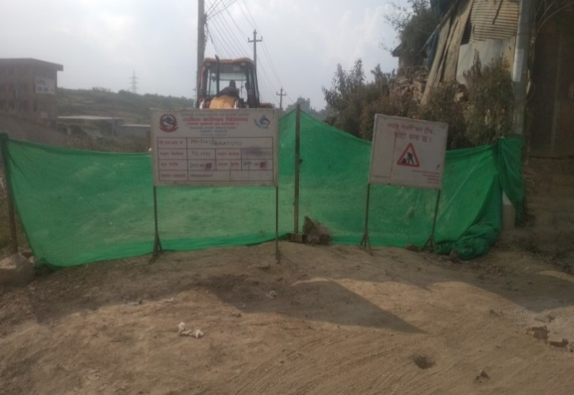 | 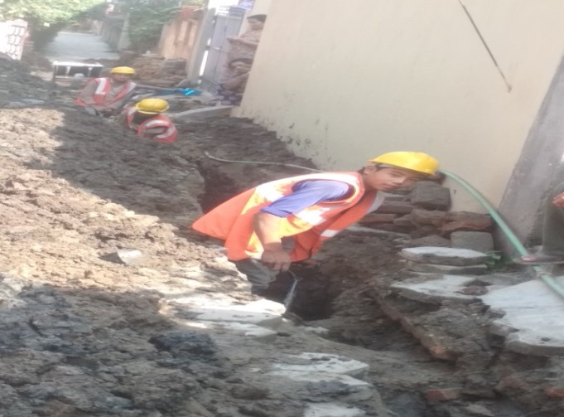
Pipeline work with proper signage boards at Balkhu, DNI Package 7A. | Pipeline work at Kuleshwor, DNI Package 7A. The site lacks temporary shifting.
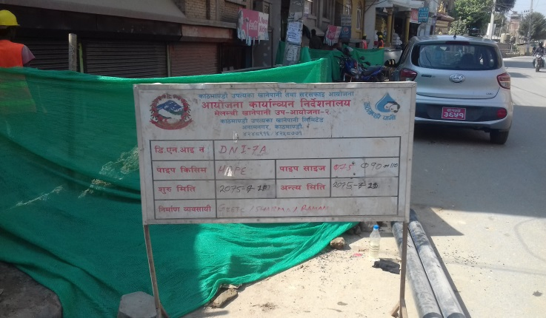 | 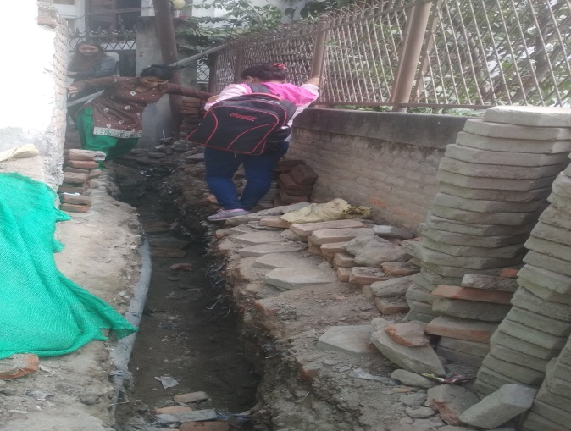
Pipeline work with proper signage boards at Balkumari, DNI Package 7A. | Locals facing problem while walking across the open trench at Kalanki Mandir, DNI 7A.
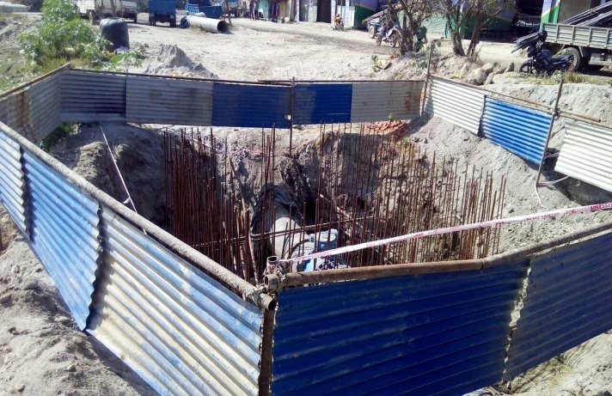 | 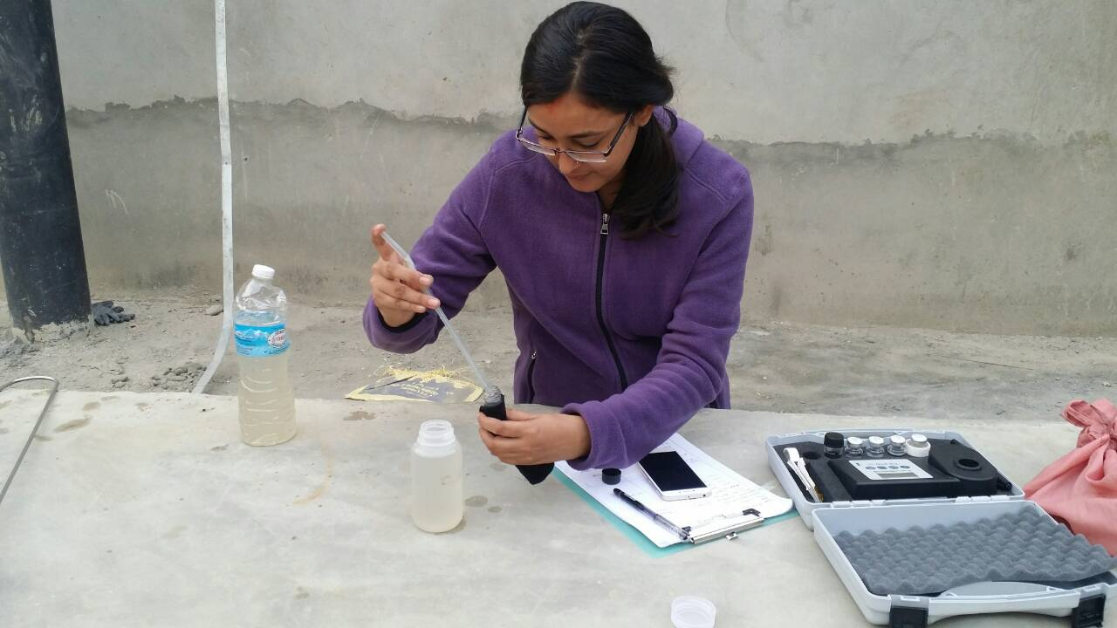
Hard Barricading done at Gokarna site. After the instruction of DSC 05, the contractors did hard barricade. | Measurement of turbidity of flushed water during commissioning at Panipokhari.
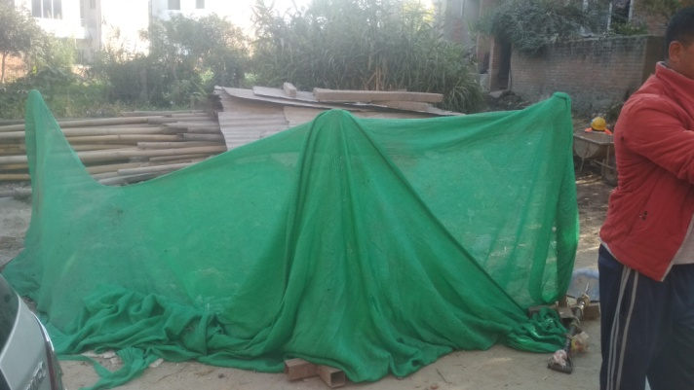 | 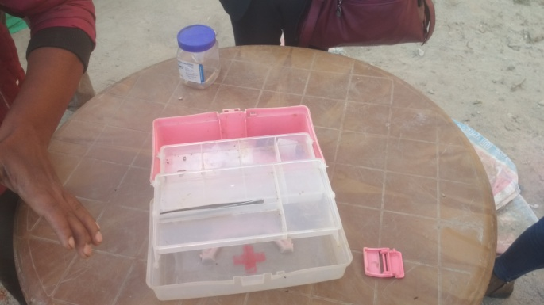
In narrow road where dump truck cannot be brought excavated soil barricaded using green nets. | Empty first aid box in Balkumari.
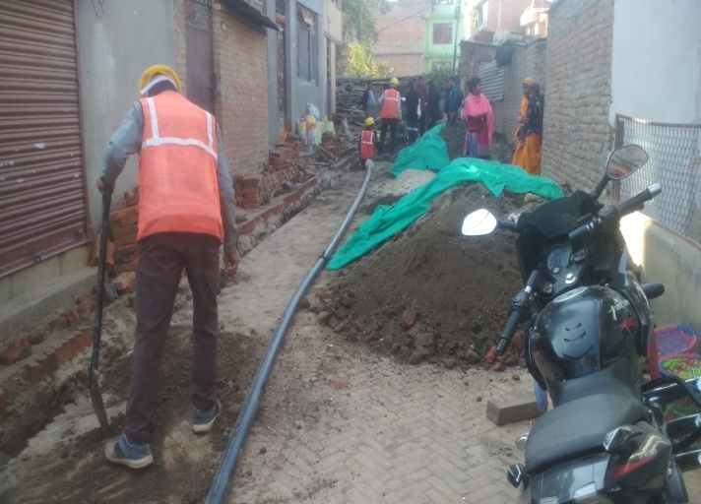 | 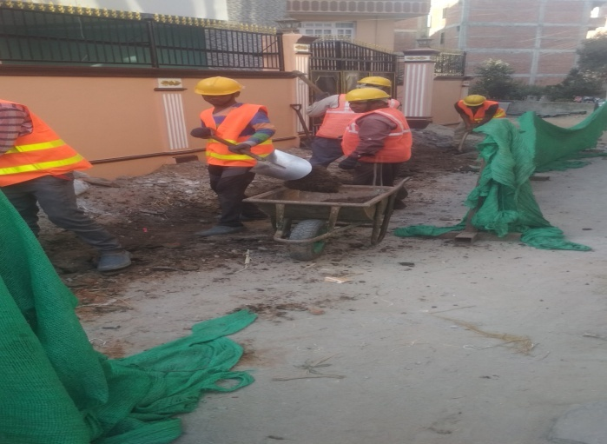
Temporary shifting of excavated soil not done in Balkumari. | Workers in their full PPEs at Balkumari.
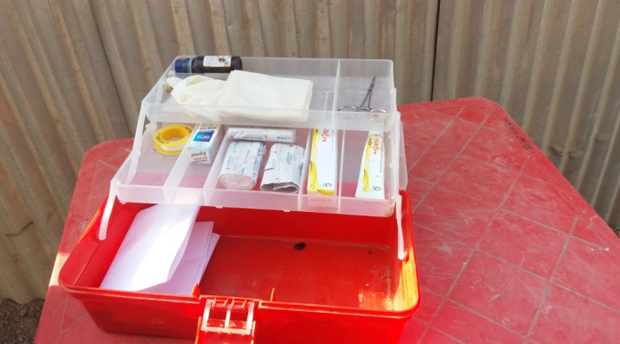 | 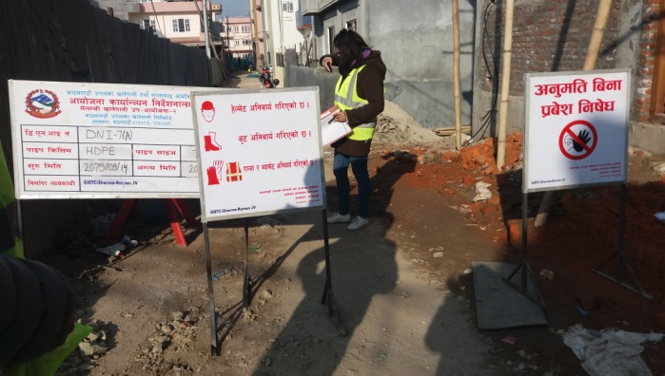
Incomplete first aid box at Balkumari | signage boards at appropriate location with complete information at Balkumari
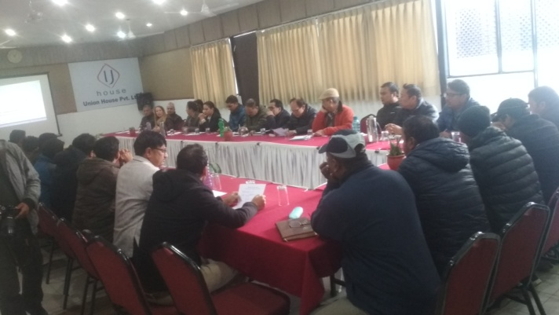 | 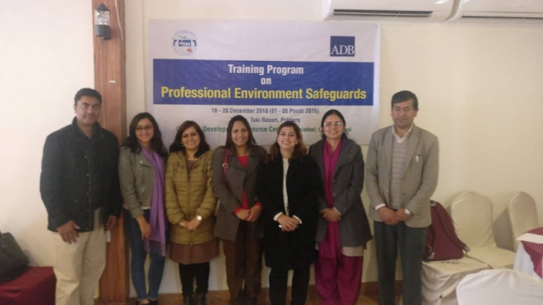
Workshop on Safeguards Compliance in presence of ADB, PID, Consultants (DSC and CASSC) and Contractors | 5 day professional Environmental Safeguards training organized by CDRC

II. Letters and Memos
(Available in Hard Copy)

III. OHS Performance Indicator
(Available in Hard Copy)

IV. Grievances Records
(Available in hard copy)

